Rising Thunder



**[logo TBD]**

**Power the machine with your thunder**

Contents

**I. Game Overview 3**

**a. Don’t let them catch you 3**

**b. Story and Themes 3**

**c. Genre 3**

**d. Target Audience 3**

**e. Platform and Tools 3**

f. Genre innovations 4

**II. Playability and Mechanics 4**

**a. Main Game View 4**

**b. UI 5**

**c. Mechanics 6**

a. Zap-zap M-Zeus 6

**b. Electricity Building 6**

**c. Quick deck change 6**

d. Overworld exploration 6

**e. Deck management 6**

f. Extra Mechanics 6

**d. Game Controls 7**

**III. Core Gameplay Loop 7**

**IV. Game Elements 8**

**a. Main Characters 8**

**b. Main Menu 8**

**c. Intro Sequence 8**

**d. End Condition 8**

**V. Sound 8**

**a. Music 8**

**b. Sound Effects 9**

**c. Voice Lines 9**

**VI. Mini Art Bible 9**

a. Art Style 9

b. Characters 9

c. Backgrounds/Levels 9

# **Game Overview**

## **Don’t let them catch you**

The player was a guard of a town, during a night the town was burnt to the ground and the player was framed of arsony after witnessing the real culprit, the town mayor; now, he wishes to find a place to hide until things calm down and is on the run, always being persecuted by the law enforcers.

While the player progresses through the game they will meet diverse law enforcers as well as some friends, they will slowly get stronger in a journey to sort out their future as well as to try to reveal the truth behind the fire.

For that, the player will have to enter amazing battles, learn from their mistakes and build a deck of various weapons and powers in a never ending battle against those that want to catch the player and a battle with their inner self (a.k.a, inner demons).

## **Story and Themes**

The story of the game will center around the player while they run away from the law and discover themselves and what they want to do in the future, hide, fight back or accept their fate. Having the main thematics of love, self blame and injustice; the more they run the more they know about what’s happening around the world and as they proceed, they will have to come to terms with their inner self and thoughts.

## **Genre**

The game is a RTS fighting game.

## **Target Audience**

The game is intended for players from older teens to early twenties.

## **Platform and Tools**

The objective is to build the game using either C++ inside Unreal engine, using a simpler engine specialised in 2D like gamemaker or using C# with godot. It is not final yet.

For the pixelart, the objective is to utilize aseprite.

## **Genre innovations**

For honesty sake, there are not many if any inovation, the original concept of this GDD was made **BEFORE**, One Step From Eden **AND** the remake from megaman battle network, the game that inspired this GDD.

I would say that the way you manage your spells is unique, also the fast pace action that is made to utilize spells without having basic/normal attacks.

# **Playability and Mechanics**

## **Main Game View**

The game will have a 2.5D pixelated isometric bird-eye view (check "octopath traveler" and "one step away from eden")

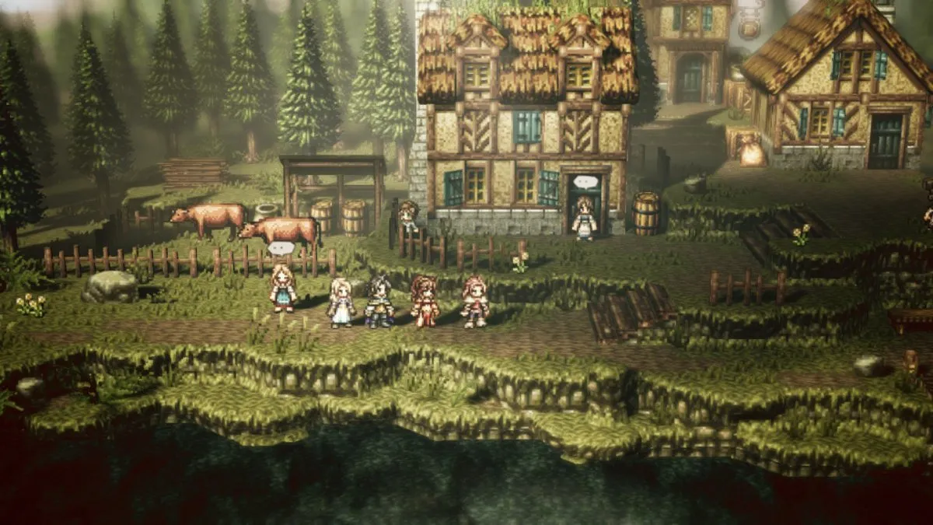

Image: Octopath traveler

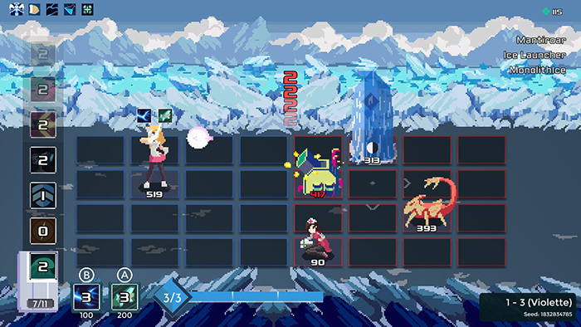

Image: One step from eden



## **UI**

The Menu UI will be displayed in a phone-like object that will use electricity currents to navigate from swipe to swipe (pages), something similar to what you find in "Fallout 4", for the game itself.

As for the overworld nothing will be shown while in the combat part you'll have a standard fighting game hp bar and “vs” on the top of the screen, on the left side it will display the powers available, and on the bottom left the electricity which will work as the mana system of the game.

## **Mechanics**

## **Zap-zap M-Zeus**

In a 1v1 fashion, battle against another player or AI using a variety of powers to hit your opponent while evading theirs.

## **Electricity Building**

Gather Different powers and add them to your collection, then choose the ones that fit the best between themselves to take to battle (think of it as deck building).

## **Quick deck change**

Each battle is a Bo3 (Best of 3) or Bo5 and at the beginning of each round the player will have a side storage with some pre-selected powers that the player will have the option to change with their current ones.

## **Overworld exploration**

Explore the overworld to find clues about the incident, gather more powers and build relationships by talking to the npc's that populate the areas you visit.

## **Deck management**

During battles, the player will have the option to utilise 2 actions to help them manage their deck/spells. The first is something akin to what tetris does, were the player will be able to hold a spell to use in the future. The second, and something more novel, is the ability to skip the speel but with the caveat that each time you do, you get a debuff until you utilize a spell, the debbufs can range from an increase of spell cost to a decrease in damage or range.

## **Extra Mechanics**

Power album (you can see all the powers you have and collect them);

Power exchange (trade powers while in the story mode);

Training mode (everything unlocked for a more fair experience);

Versus mode (play against other players, option to use a cheat code and unlock every base game power/character)

## **Game Controls**

The objective is to give full key bind control, but for a standerdize view, the following table has a proposition of what to press to play the game

| Key binds | Function |
| --- | --- |
| W, A, S, D | Standard movement (up, left, down and right respectively) |
| Shift | Overworld: sprints  Combat: Hold ability |
| Mouse | Overworld movement, same as “WASD”, and UI interactivity |
| Escape | Open menu |
| E | Interactions, same as Mouse on the overworld |
| Q | Combat: Use special |
| Space | Combat: Activate Ability |
| CTRL | Combat: Discard ability |
| M | Open Map |

# **Core Gameplay Loop**

**Story mode:**

* Get quests→ Explore→ Battle→ Get new cards→ Rearrange your deck→ Repeat

**Versus Mode:**

* Build a deck→ Battle 1° round→ Small changes to deck→ Battle 2° round→ If tie, last deck changes and→ Last round → Repeat

**Battles:**

* Move→ Defend or Attack→ Manage mana → Repeat

# **Game Elements**

## **Main Characters**

* **[MC name]: Titus Lung**

Titus is a compassionate person that likes to help those close to them, but a bit indifferent to those they’re not so close with, they can appear cold sometimes but when people really get to know them they see that under their tough exterior lies a soft heart full of uncertainty and self doubt.

## **Main Menu**

Before you press start and if you spend some time without moving the menu a pre-recorded fight will be shown and chosen randomly, after pressing start you will have on the left side the text that corresponds to the options you can choose (story, vs, game options, etc.) and the right will have images of the game/characters that change with the hovered option.

## **Intro Sequence**

The game (story) will start with Titus waking up noticing the fire and trying to put it out, after failing for some time they notice some people calmly speaking, they chek ti out and notice that the mayor is giving orders to some guards to disrupt the efforts to put out the fire, they get noticed and start running away while hearing something akin to “Don’t let them escape”.

## **End Condition**

The story mode will end when the player reaches the last area of the game and fights the final boss, the mayor, reaching the apex of his journey.

The VS mode does not have an end, but will have a ranking system to accommodate competition and a goal/incentive to keep playing.

# **Sound**

## **Music**

TBD

## **Sound Effects**

TBD

## **Voice Lines**

TBD

# 

# **Mini Art Bible**

## **Art Style**

TBD

## **Characters**

TBD

## **Backgrounds/Levels**

TBD

**The team:**

**Francisco Borges: fjoborges@gmail.com**